Suffolk on the fast-track towards complete council restructuring and devolution
Suffolk is one of only a handful of areas on the government’s new fast-track Devolution Priority Programme (DPP).
- Ministers wants Suffolk at the front of the queue
- Suffolk’s county, borough and district councils to be abolished
- Work starts on reorganisation plan for new unitary council or councils
- Government proposes postponing county elections to facilitate rapid change
- Mayor set to be elected in May 2026
Suffolk’s 50-year-old two-tier council structure is set to change with the government proposing to abolish county, borough and district councils and replace them with a new unitary council arrangement and a directly elected mayor.
Under the proposals, all six of Suffolk’s district, borough and county councils would be disbanded and just one authority would provide all councils services in an area. The government argues that unitary councils can deliver better outcomes for residents and save money that can be reinvested into public services.
Angela Rayner MP, the deputy prime minister and secretary of state for housing, communities and local government, announced that Suffolk is one of only a handful of areas on the government’s new fast-track Devolution Priority Programme (DPP) which would also see the election of a mayor (covering Suffolk and Norfolk) in May 2026. The mayor would take control over strategic policy areas like transport infrastructure, economic development, health improvement and blue light services – along with devolved government funding to deliver positive change.
Devolution would happen alongside local government reorganisation in Suffolk.
Councillor Matthew Hicks, Suffolk County Council’s leader, said:
“Devolution and council reorganisation will mean we can secure and free up funding to plough directly back into public services that benefit our residents.
“This is a major win for Suffolk and one that will be welcomed by those who want to see efficiency, accountability and streamlined delivery of council services. To achieve this, we want to work with residents, businesses and partners to deliver the best possible outcome for Suffolk.”
To facilitate change of this scale and at this pace, the government will table legislation to postpone Suffolk County Council’s May 2025 elections. This is the case in other areas currently undergoing devolution and reorganisation – a precedent set when areas such as Somerset, Cumbria and North Yorkshire underwent the same type of changes.
Last month, Suffolk County Councillors voted to put Suffolk forward for the DPP, following an invitation from ministers.
Now that Suffolk has been invited onto the DPP, the government will launch a public consultation on the devolution (mayoral) elements of their proposals. Simultaneously, Suffolk County Council will research, write, engage on locally and then submitted to government a detailed business case for council reorganisation. Areas only have until September 2025 to submit their complete plans. A government-led public consultation on the local government reorganisation proposals will follow the business case being submitted.
At this stage no decision has been made on whether Suffolk would be covered by a single or multiple unitary councils.
Council making net zero gains, but still work to do
Suffolk County Council continues to bring down its carbon emissions, with significant reductions from council-owned street lighting, vehicles and buildings, but there is still work to do to reach its ambitious target of net zero by 2030
Suffolk County Council continues to bring down its carbon emissions, with significant reductions from council-owned street lighting, vehicles and buildings, but there is still work to do to reach its ambitious target of net zero by 2030.
A report going to the council’s Cabinet reviews progress since the declaration of a Climate Emergency in 2019. The report finds that emissions across the areas within the council’s direct control, such as energy consumption in council buildings and vehicles (categorised as Scope 1 & 2 emissions), have fallen by a further 8% over the past year, contributing to a 43% drop since 2019. When taking account of the council’s switch to a renewable electricity tariff, this becomes a 75% reduction.
However, when calculating its overall net zero progress, the council also reports on many emissions where it has influence but less direct control. These are known as Scope 3 emissions. These include things like home to school transport, home-working, and staff commuting and travel for work in their own vehicles.
These make up 65% of the council’s reported emissions, which the council is currently projecting will reduce by 48% by 2030 showing the scale of the remaining challenge.
Suffolk County Council Scope 1 & 2 Budget and Forecast Pathway
We’re making great progress in areas where we have most control, such as our buildings, vehicles and energy use. It’s no secret that there’s still much work to do. Specifically, the Scope 3 emissions that we report on, which is our biggest challenge to achieving net zero.
Since 2019, when it declared a climate emergency, the council’s carbon reduction successes include:
- Street and traffic lights down by 57%
- Diesel and petrol vehicles down by 50%
- Gas and oil use in buildings down by 37%
- Staff commuting down by 30%
- Electricity use in buildings down by 25%
Nationally, the council is making impressive strides with its own estate, standing out as one of the three leading county councils in England for reductions on Scope 1 & 2 emissions, according to analysis of published reports.
Councillor Philip Faircloth-Mutton, Suffolk County Council’s Cabinet Member for Environment, Communities and Equality, said:
“Overall, our carbon emissions have decreased by 7,740 tonnes CO2e since 2019, which is encouraging.
“We’re making great progress in areas where we have most control, such as our buildings, vehicles and energy use. We are also seeing a long-term reduction in our costs - saving more than £500,000 on energy bills for our buildings alone as a result of this work.
“With the successes we’re having with reducing emissions and energy bills in our own buildings and operations, I hope we can be an example to other Suffolk businesses that, no matter what their size, can succeed on their net zero journeys too.”
“Although our latest report suggests that we are not on currently course to meet our net zero target across all scopes, as new products, services and opportunities become increasingly available, I think greater reductions will be achievable.
“It’s no secret that there’s still much work to do. Specifically, the Scope 3 emissions that we report on, which is our biggest challenge to achieving net zero.
“While most of these emissions are beyond our direct control, we still include the data in our overall progress as they are still driven by council activity.
“Despite these challenges, we remain firmly committed to carbon reduction and continue to embed climate action in everything that we do.”

Natural Landscape – grants open
Amenity and Accessibility Fund - APPLY NOW!
https://coastandheaths-nl.org.uk/managing/grants/
Closing date: 3rd March 2025
Geographic area: The specific Amenity & Accessibility Fund area.
Project delivery time-frame: April 2025 to 12th March 2026
Amount you may apply for per application: No limit but as a guideline you may wish to consider applying for in the region of/up to £2,500
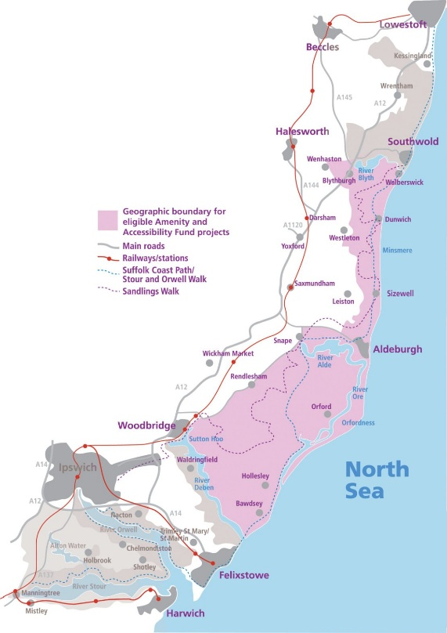 map of elidable applications
The Galloper Wind Farm Fund (GWFF) aims to contribute to the appearance, setting, conservation, amenity, accessibility and enjoyment of the Suffolk & Essex Coast & Heaths National Landscape specifically within the area defined as a 5km radius of Sizewell, the location of the Galloper substation.
Who can apply
- The Fund is open to organisations or groups from the public, private, voluntary and community sectors from within or outside the National Landscape, where projects benefit the Fund area
- Whilst applications from individuals are not precluded, there needs to be demonstrable wider public benefit and support for the project. It is expected that in most cases applications will be submitted on behalf of organisations or groups of people
- Applicants need not necessarily come from, or be based in, the National Landscape. However, projects must further the community, conservation and access objectives of the National Landscape and we would expect to see evidence of support for the project from the local area. Please look at the website for more information.
- Aldeburgh is eligible to apply for all of the Suffolk & Essex Coast & Heaths National Landscape grants.

N.B. only Northern parts of Aldeburgh closer to Thorpeness are eligible to apply for the Galloper Wind Farm Fund as the fund is for a 5km diameter of Sizewell, including Leiston. Applications from projects close to the boundary will be considered where benefits to the geographic area of the fund are demonstrated e.g. project delivery may benefit Leiston and Sizewell communities also.

https://coastandheaths-nl.org.uk/managing/grants/gwff/galloper-wind-farm-fund-criteria-and-guidance/#wjhsyzzolchhgleasqvdnkmmtxialdlfkhpf
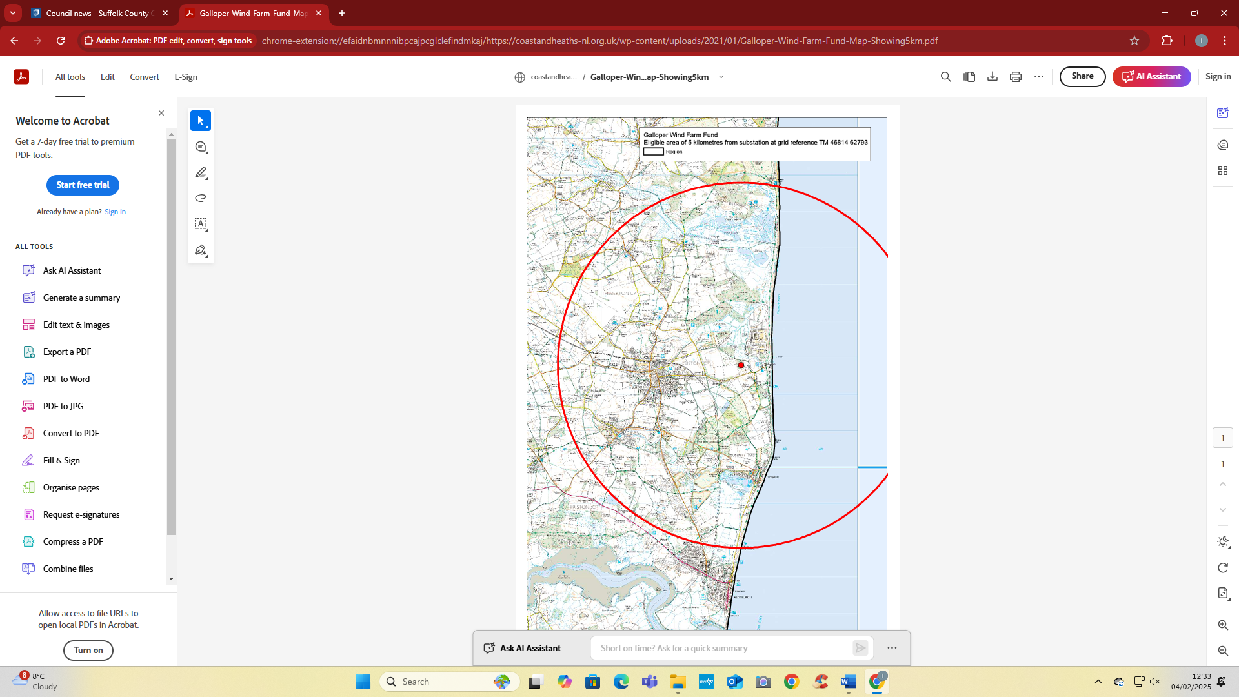

Stay alert - how to beat the cold callers and scammers
Scammers and cold callers appear to have re-surfaced in Suffolk again.
In the last few days Suffolk Trading Standards has warned of individuals cold calling at properties in Brandon, offering window and conservatory installations.
Trading Standards are reminding people of what to do to avoid falling prey to unscrupulous doorstep traders.
Trading Standards have also learned of an Ipswich resident who was approached by a trader advising their roof needed to be replaced.
A contract for £25,000 was agreed for the roof replacement and a further £2,500 for scaffolding to be erected. The resident paid £2,500 but as the scaffolding was being installed a neighbour, who is a structural engineer inspected the roof and was able to confirm no work was required.
Calls have also been received by residents across Suffolk from a company saying they need to come and inspect solar panels on the property. The trader is very forceful and aggressive, insisting that they will visit.
There are also reports of traders going door to door in Stanton, Bury St Edmunds, offering to clean the guttering of the property.
Trading Standards advice is to never agree to anything, including a home visit, when approached by a cold caller on the phone, at your door or via email. Do your research first and find out if it is a product or service that you want or require. While it might be tempting to agree to low prices being offered on the doorstep, think twice. It’s an old adage but it still applies today – if it looks or sounds too good to be true then it’s because it is.
Never agree to have any work done because of a cold call, and don't be pressurised into having the job done immediately
If you think work needs doing to your home, get quotes from two or three traders. Ask friends and family for recommendations of traders who have carried out work for them. You can also check Suffolk Trusted Trader for traders that have been vetted and approved by us at https://trustedtrader.team/Suffolk/
Ask for the full name & address from a trader before considering dealing with them, and never rely solely on a mobile phone number
Ask for a written quotation detailing all the proposed work and a final price for the job BEFORE the work is started
Only pay in full once the work is completed to your satisfaction and don't pay cash
Please report all doorstep callers to Trading Standards via Citizens Advice Consumer Service on 0808 223 1133.
In the case of doorstep cold callers, you can protect yourself and your neighbours by nominating your area to become a No Cold Calling Zone.
There are now more than 250 across the county, and while the more brazen cold callers will still try their luck the zones do act as a deterrent - 91% of residents surveyed last year said they had received less or no doorstep visits since the introduction of their zone, with 94% of residents saying they feel safer.
Anyone wishing to nominate their road should go to the No Cold Calling page on the Suffolk County Council website.
Or, if you would like to receive a free No Cold Calling sticker for your door, please email your address to trading.standards@suffolk.gov.uk.
Let’s be clear. These doorstep traders are ruthless.
They usually target the vulnerable and are very persuasive, delivering poor, shoddy work then all too often just disappear, leaving their victims out of pocket.
Similarly, scammers strike through phone calls, letters, emails, the internet or at your door.
The saddest part of it all is that victims are often left feeling a sense of shame and embarrassment, and they really should not - it can happen to anyone.
But by staying on our guard, for ourselves and for vulnerable family or friends, we can beat the scammers and rogue traders.

Best wishes
TJ

Not much to add to last months, however, any updates will be sent through.

As the dates of the SZC works are changing it is again suggested to use the SZC tracker for the projects
Track a Project - Sizewell C Works Tracker
Or One Network to track traffic management.
https://one.network/
One matter that should be made clear as that with many of the road closures and speed limits SZC are doing these under powers granted to them by the DCO. These powers allow them to prohibit all use except for pedestrian access for those having land or property within the closure as far as practicable.
high-level summary
- Park and Ride Sites – archaeological investigation ongoing at both. Close to agreeing the design of the NPR but there will be around 6 – 8 weeks from now before the supporting legal agreements and requirements are discharged to allow work on site. Note that the roundabout on the A12 is TEMPORARY. Willow Marsh Lane is closed and will remain so although the comments about inactivity have been noted. Working with SZC to see what pedestrian access can be provided to mitigate the impacts of the closure.
- Deed of Obligation Schemes. These are still progressing through the design stage. With respect to the Leiston Town Centre scheme, awaiting a date form SZC when they will undertake the next round of public communication (not consultation).
- Sizewell Link Road – entering final design iteration for review. Archaeological investigations and site clearance ongoing. This may require traffic management on some of the minor roads.
- Two Village Bypass – as SLR but latter in the program. Archaeology ongoing at Tinkers Brook.
- A12/A1094 Friday Street Roundabout – design mostly agreed in principle. Current position is that SZC should still commence the work before SPR commence EA2. The works will require several closures of the A12 and A1094 but the programme for these is not yet available.
- A12/B1122 Yoxford Roundabout – design approved. Waiting on drainage consent for River Yox before completing legal agreement and discharging highway requirement. Note that the intention is that all the work in Yoxford include the SPR mitigation is carried out as one project to reduce disruption.
- AD4 Rail works – still awaiting highway design for level crossing improvements. There will be some local overnight road closures for surveys on Knodishall, Saxmundham Road and Leiston level crossings over the next few weeks.
- Announced at Wednesdays transport forum that the rail closure at Saxmundham has been delayed until next year (February) but awaiting confirmation of this from SZC.
- AD6 Leiston: Main focus of work. Utility works are requiring a round of road closures and temporary traffic management on Lovers Lane (water and power) , B1122 Abbey Road (power, MDS site access), Eastbridge Road (power).
- Abbey (or Aldhurst) Lane is closed and will remain so. The diversion was changed to the B1119 and B1122 following complaints about use of George Road / Moat Road. Also that we advised them that the latter diversion would not be practical once the SPR work starts and also clashed with work on the B1122 Abbey Road. It is understood that an agreement has been reached to allow farm machinery through the closure.
- The highway works are a major priority for SZC
- Traffic Monitoring and reporting
- In general compliance with the CTMP has been good and numbers of HGVs lower over the autumn than they were in the summer. Obviously, this will start to pick up as construction ramps up as will numbers of workers.
- The traffic data collected in October has been published and another round due. Four additional sites have been added in Leiston and one in Knodishall to monitor traffic on the B1069.
- Average speed cameras for the B1122 and B1125 are still scheduled.
- TCPA for Aldhurst Visitors Centre is still with ESC for decision.

SPR
- Latest information is that commencement of EA2 will be in the summer but that there will initially be less HGV traffic than expected (100 HGV movements / day, ie 50 deliveries, rather than worst case forecast 270/day until March 2026) There are issues with SPR traffic going through Friston, trying to get SPR to resolve this.

Draft Heads of Terms have been sent to landowners/clubs etc on the Sea Link route with expectations of notice of the DCO very soon.
As per previous updates it is crucial that people monitor the Tec register/national grid websites/trackers etc

