Happy New Year.
2025 starts off pretty much the same as 2024 did with an energy consultation ending. Advance thanks to all those residents and groups that responded and to everyone that shared or conveyed information to others. On the 12^{th of} December at an SCC full council meeting, I took the opportunity, whilst seconding a successful motion for the leader, to once again highlight and bring my divisions focus and concerns regarding the energy projects. **
It is vital that people and groups consider registering their participation, a useful video about participating can be viewed: https://infrastructure.planninginspectorate.gov.uk/application-process/participating-in-the-process/ (4) (3.27)
As you know, you can keep up to date and register for updates Sea link https://national-infrastructure-consenting.planninginspectorate.gov.uk/projects/EN020026
Latest changes to Sea Link plans are not enough
Suffolk County Council continues to object to proposed plans for National Grid’s Sea Link project, despite recent changes to the scheme.
The council still has concerns regarding significant issues, including:
- Permanent access to the converter station site, resulting in the potential for construction traffic seven days a week
- Core working hours at the site of 7am to 5pm on Sundays and Bank Holidays, giving no respite to local residents and businesses
- The unsuitability of Benhall Railway Bridge as an access route, including the potential for dangerous queuing of traffic on the A12 during construction
- A survey of the Benhall Railway Bridge, commissioned by Suffolk Highways has highlighted significant concerns regarding its capacity to accommodate abnormal loads
- Plans to relocate of the Fromus Crossing bridge further north, with a still-expected height of up to 6 metres, are likely to result in notable impacts to heritage assets
The lack of any movement from National Grid is frustrating as we continue to press the case for a coordinated access solution between the major energy infrastructure projects in the area.
The council believes that a coordinated and integrated access solution between the major energy infrastructure projects affecting the county, including Sizewell C and National Grid, would considerably reduce many of these specific issues and community impacts.
Councillor Richard Rout, Suffolk County Council’s Deputy Cabinet Member for Nationally Significant Infrastructure Projects, said:
“We have no option but to continue to object to National Grid’s plans which would not only have stark environmental impact but remain wholly unacceptable to local residents and businesses.
“The lack of any movement from National Grid is frustrating as we continue to press the case for a coordinated access solution between the major energy infrastructure projects in the area, should they go ahead.
“As an example on the Sea Link project, we have repeatedly engaged with National Grid to propose alternatives to the Fromus Crossing – the plans to move the crossing, 40m to the north, will result in a greater visual impact on the key views from the south of the conservation area, the Grade II Church of St John the Baptist, and the Grade II listed Hurts Hall.
“The council also has significant concerns regarding the capacity of Benhall Bridge to accommodate the huge abnormal loads that National Grid propose. Taking this route not only risks huge delays to other traffic but the required improvements, if indeed they are possible to deliver, risk disruption on a key rail route that, as well as serving local residents, will play an important role in the construction of Sizewell C.
“We have always acknowledged the need to increase domestic energy generation and deliver energy security to the UK. But this must not happen without due consideration for our local communities.”
Suffolk County Council formally objected to National Grid’s Sea Link project in August 2024, citing the concerns above, among others.
None of National Grid’s recent changes will affect this position, and the council has outlined many more technical concerns in its latest response to the plans .
The council has also noted significant public interest in the design process of the converter station site. It urges National Grid to publish the findings of the Design Review Panel to help all concerned to understand the design approach to the converter station site.
National Grid expects to submit its application for development consent in early 2025.

Unique landscape to be changed forever by pylons
A large area of landscape on the Norfolk/Suffolk border with particular uniqueness, rivalling those of other nationally protected landscapes, is set to be decimated by pylons as part of National Grid’s Norwich to Tilbury project
A large area of landscape on the Norfolk/Suffolk border with particular uniqueness, rivalling those of other nationally protected landscapes, is set to be decimated by pylons as part of National Grid’s Norwich to Tilbury project.
In a letter to both Norfolk County Council and Suffolk County Council, and other local leaders, National Grid has outlined that it has decided to install overhead lines through the Waveney Valley, rather than running cables underground, as they had set out in their previous consultation.
We have worked closely and in good faith with National Grid, and yet they have not delivered a fair deal for the local area. There is nothing on the table from them, or Ofgem, to soften this blow.
Councillor Richard Rout, Suffolk County Council’s Deputy Cabinet Member for Nationally Significant Infrastructure Projects
This is a significant blow to local communities and the natural environment, especially following last year’s Valued Landscape Assessment, a report jointly commissioned by Norfolk County Council and Suffolk County Council.
The report concluded that “the length of the Waveney Valley expresses many special qualities, and in the context of Suffolk and Norfolk, it is considered to be a valued landscape. Conserving and enhancing the special qualities articulated in this report is a key aspiration of existing planning policy.”
Councillor Richard Rout, Suffolk County Council’s Deputy Cabinet Member for Nationally Significant Infrastructure Projects, said:
“This decision not to underground any of the proposed pylons through the Waveney Valley, is nothing short of contemptible. The study we commissioned saw the area recognised as a valued landscape and National Grid’s plans will wreak untold damage on it. There was a clear alternative to this and they’ve chosen not to take it.
“What I find particularly flagrant - if this what National Grid will press ahead with - is a lack of any suggestion of mitigation or compensation package for the local area.
“This council has engaged fully with discussions and consultations on Norwich to Tilbury, providing additional evidence to help protect the affected communities and environment in the Waveney Valley. We have worked closely and in good faith with National Grid, and yet they have not delivered a fair deal for the local area. There is nothing on the table from them, or Ofgem, to soften this blow.
“Yet again, I see this as more evidence of the government’s short-sighted and rushed mission to decarbonise the grid by 2030. Their influence is pushing through the cheapest and fastest options, with no consideration for local residents, businesses or the environment – we are still to see any progress from them on community benefit schemes, to support situations just like this.
“As a council, we still maintain that the opportunity to underground the whole pylon run between Norwich and Tilbury, using HVDC cables, has not been properly explored. Revisiting the 2030 decarbonisation target and pausing the project would allow that to happen."
Councillor Kay Mason Billig, leader of Norfolk County Council, said:
“The decision by National Grid to plough on with the destruction of our countryside is disgraceful. There seems to be a determination to create an energy wasteland across Norfolk and Suffolk, with no regard for the local impact.
“The Waveney Valley is well known for its unspoilt rural tranquillity, historic buildings and rich natural habitats. National Grid have clearly disregarded local views and seem determined to cover the landscape with miles of pylons.
“We recognise the need to create a secure and clean energy system, but this can’t come at the unmitigated expense our communities and natural environment.
“National Grid have not provided any benefits for local communities or businesses associated with their current plans to upgrade the transmission network. There is no clear plan to upgrade the existing energy infrastructure in Norfolk needed to deliver new homes and jobs. National Grid’s current plans will simply see electricity generated from offshore wind passing through the county with no tangible benefits for Norfolk as a whole.”
The councils will now look to take up their concerns with National Grid and discuss the issue further.
Council’s budget prioritises vulnerable residents and essential services
Suffolk County Council has unveiled its proposed budget for 2025/26, with a strong focus on supporting vulnerable residents across the county.
Under the proposals, the council’s net budget would rise by 6.7%, from £752.9 million in 2024/25 to £803.7 million in 2025/26. Key allocations include:
- £18.1 million extra for children’s services, ensuring continued support for young people and families in need
- £35.2 million extra for adult care, aimed at addressing the growing demand for social care services.
To help fund these essential services, the council is proposing a 4.99% rise in Council Tax. This would consist of a 2.99% increase in general Council Tax and an additional 2% specifically for adult care services.
This means the costs for a household would be:
- Band B property: £24.67 per week, a £1.17 increase from 2024-25
(Band B properties are the most common in Suffolk)
- Band D property: £31.72 per week, a £1.51 increase from 2024-25.
The council will also receive £12.1 million of the additional £880 million allocated by the government for adult and children’s social care. It also expects to receive £2.2 million of the £263 million earmarked for a new Children’s Services Prevention Grant.
To balance the books, the council has also identified £10.9 million in additional savings, building on the £17.5 million approved last year. This brings the total savings to £28.4 million for the 2025/26 financial year.
Cllr Richard Smith MVO, Suffolk County Council’s deputy leader and cabinet member for finance, economic development and skills, said:
“We remain committed to supporting vulnerable children and adults in Suffolk. Despite the financial challenges posed by increasing demand and broader economic pressures, we are proposing a balanced budget without drawing on unallocated reserves.
“It is deeply disappointing that, despite our significant deprivation levels, Suffolk will receive nothing from the government’s new £600 million Recovery Grant. Further, the scrapping of the Services Grant and Rural Services Delivery Grant will see £3.7 million struck from our budget.
“Nevertheless, we understand the pressures facing families and businesses in Suffolk, and that is why we will continue to ensure every pound we spend delivers the best value for our residents.”
The budget proposals will be presented at a Scrutiny Meeting on Tuesday, 14 January 2025. The meeting will be live-streamed on Suffolk County Council's YouTube channel, and relevant papers can be viewed on the committee minutes page.
The final budget will be debated and voted on at a Full Council meeting on Thursday, 13 February 2025.
Reminder - Primary school application deadline approaches
Parents and carers have until Wednesday 15 January 2025 to submit an application to secure their child’s place at a primary, infant or junior school for September 2025. Applications should be made for children born between 1 September 2020 and 31 August 2021 who are due to start primary school from September 2025.
An application for a full-time school place must be made even if a child is already attending a nursery class in an infant or primary school, a pre-school or a family hub next to a school site.
To have the best chance of securing a place at their preferred school, parents and carers need to apply for a school place by the closing date of 15 January 2025. It is important that parents and carers consider how they will get their child to and from school before making a school application. We also recommend applying for more than one school and up to three schools can be listed in order of preference.
If you are planning to move house, or you think your circumstances may change before September, it is still essential to make an application on time using the child’s current address. Further information to help parents and carers with this process is available at www.suffolk.gov.uk/admissions.
Applications should be made online as this will mean parents and carers will receive a confirmation of their application. They can then log onto the online service on the National Offer Day (Wednesday 16 April 2025) to see their school place offer and they will also be sent an email to confirm this offer on the same day.
If a parent or carer is unable to apply online then they should complete a paper application (CAF1), however these cannot be acknowledged, so it is suggested parents and carers obtain proof of postage. For those who completed paper applications, offer letters will be sent out by second class post on the National Offer Day.
School Travel eligibility is based on a child attending their nearest suitable school that would have had a place available. This might not be the catchment area school. To find out more about SCC’s school travel policy please visit www.suffolkonboard.com/schooltravel.
Applications can be made at www.suffolk.gov.uk/admissions, where further advice and guidance is also available. Alternatively, parents and carers can call 0345 600 0981 for a paper application (CAF1).
Last year, Suffolk County Council offered 96.5% of children a place at the primary school their parent or carer listed as their first preference when they applied on time. If parents and carers do not apply by the closing date, their application may not be dealt with until after places have been offered to those who applied on time.

Suffolk and East of England councils seek fairness in the face of energy projects
Suffolk County Council is joining with other local authorities in the region to challenge National Grid and the government on energy projects, demanding fairness for their communities and environment.
The county councils from Suffolk, Essex, Norfolk and Lincolnshire all face similar challenges with Nationally Significant Infrastructure Projects (NSIPs) being planned for their counties.
These are typically related to energy projects, including solar farms, wind turbines, pylons and the infrastructure associated offshore wind farms, such as substations and cabling.
Many energy projects significantly threaten Suffolk’s best and most versatile farmland, our rural communities and landscape.
Two of Suffolk County Council’s main concerns, shared with the other counties, are:
- The uncoordinated approach to NSIPs - this is creating significant challenges for Suffolk’s rural communities under the current planning policy as applied by the planning inspectorate and Secretary of State
- The government’s 2030 target for decarbonising the electricity grid – this is too hasty, making it impossible to deliver alternative solutions to pylon projects like Norwich to Tilbury
Councillor Richard Rout, Suffolk County Council’s Deputy Cabinet Member for Nationally Significant Infrastructure Projects, said:
“Along with colleagues from neighbouring county councils, we are asking government and National Grid for fairness to our communities.
“Unbelievably, many energy projects are simply not being coordinated, even those proposed by the same umbrella organisation. This means upheaval for local communities, unnecessary infrastructure, construction and disruption – all of which is preventable, if only there was some organisation.
**
“Successful motions at our full council meeting (12 December 2024), saw references to the impacts that significant energy projects will likely bring to Suffolk – which are also felt across Essex, Norfolk and Lincolnshire. For example, many energy projects significantly threaten Suffolk’s best and most versatile farmland, our rural communities and landscape.”
Suffolk County Council has had a longstanding position to support the need for low carbon energy to provide energy security for the country, and the progress to net zero – but not at any cost.
Cllr Rout continues:
“The government’s urgency to decarbonise the grid by 2030 is causing damaging decision-making and threatening the food security, habitats, and natural beauty of our countryside and its communities.
“It means the only solution for grid upgrades to projects like Norwich to Tilbury, are pylons. There are other viable alternatives, such as offshore or underground cabling. These options have still not been properly costed, despite what the government or National Grid may say, and are likely to prove more beneficial and efficient if given suitable consideration and time.”

Council calls on government to prevent scrapping of influential department
The proposed ditching of a Civil Aviation Authority department could risk the safety of Suffolk communities, local airfields and their users.
The CAA is intending to close down its Airfield Advisory Team.
Through its work on major infrastructure projects, officers at Suffolk County Council have learned that the team will not be available to provide advice to planning officers or planning inspectors after March 2025.
Suffolk County Council has written to Mike Kane MP, Minister of State for Aviation, to review the proposal.
Without such expertise, considerable projects such as pylon runs or solar farms could end up being put in ill-informed locations, risking the viability of existing airfields, and the safety of those that use them and who live and work nearby.
The Airfield Advisory Team has been instrumental in helping to shape improvements to infrastructure projects and informing planning across Suffolk. This includes the proposed Norwich to Tilbury pylon project, as part of National Grid’s ‘Great Grid Upgrade’ and other proposed energy projects such as solar farms and wind turbines.
Without this team, it is anticipated that there will be no robust and effective advice to support the design and delivery of new infrastructure projects, and that this will compromise scrutiny of their design and delivery.
The impact of obstructions such as where pylons are placed or the glare from solar farms may also limit the commercial, strategic, and recreational operation of airfields across Suffolk and the rest of the country.
Councillor Richard Rout, Suffolk County Council’s Deputy Cabinet Member for Nationally Significant Infrastructure Projects, said:
"The effective and technical advice that we have received from the Airfield Advisory Team has been essential to a number of projects that we respond to, on behalf of Suffolk’s communities.
"As an example, they have directly helped with making improvements to the Norwich to Tilbury pylon project, to lessen the impact on Suffolk residents and businesses.
"Without such expertise, considerable projects such as pylon runs or solar farms could end up being put in ill-informed locations, risking the viability of existing airfields, and the safety of those that use them and who live and work nearby.
"As such, we have written to the Minister for Aviation, asking that he work with the CAA to reconsider the scrapping the Airfield Advisory Team."
In July 2024, Suffolk County Council raised its concerns about the proposed Norwich to Tilbury pylon project when it formally objected to plans, published at the time.
Amongst a number of fears, it cited that there would be “serious implications on nine airfields” with pylons close to runways which, in some cases, could possibly stop flying all together.
Suffolk County Council’s letter to Mike Kane MP, Minister of State for Aviation, can be read on suffolk.gov.uk
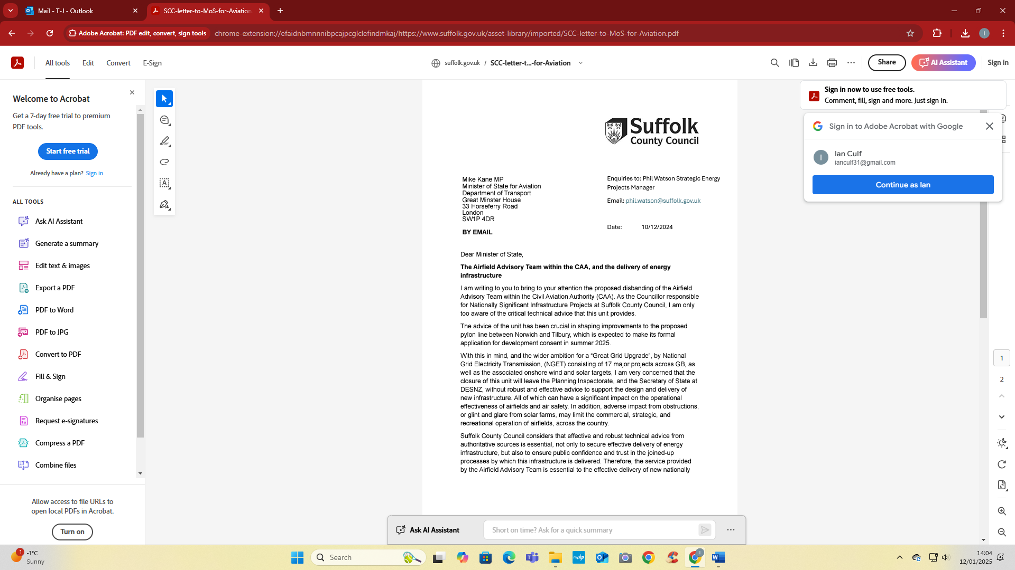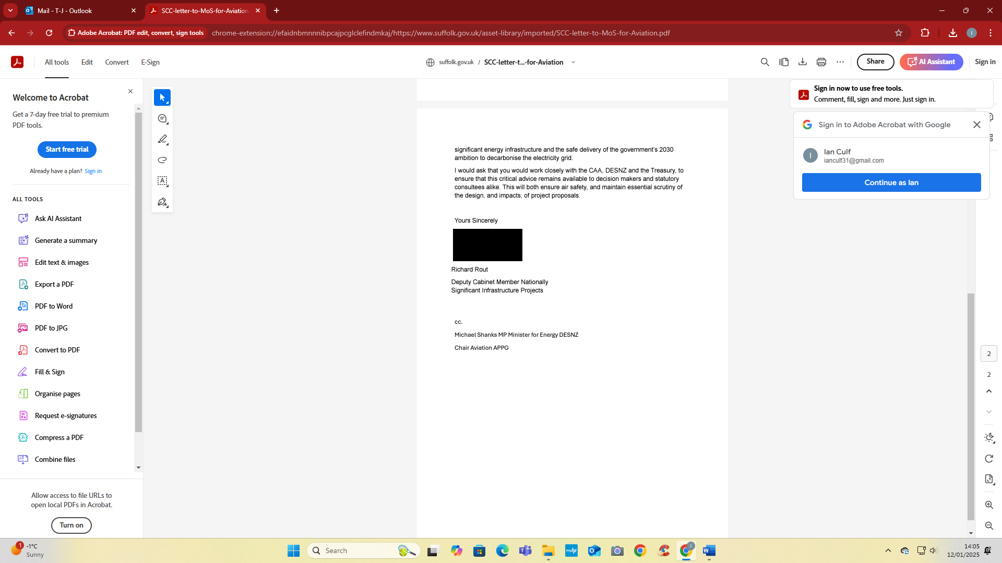
(word version – click and drag to make larger to read)

Suffolk commits to devolution fast track
Suffolk should be fast tracked for devolution and local government reorganisation, councillors have decided.
Following an invitation from ministers, Suffolk County Council’s Cabinet today agreed to recommend Suffolk for inclusion in the government’s Devolution Priority Programme (DPP), which would see the creation of a directly elected Mayor (likely covering Suffolk and Norfolk) and the replacement of existing council structures with a streamlined unitary council being set up.
The decision followed a debate and vote at a meeting of all county councillors.
Speaking following the debate, Councillor Matthew Hicks, leader of Suffolk County Council, said:
“Today marks the start of arguably one of the biggest decisions this council will take in its 50 plus-year history.
“We need to think what is best for the people and businesses of Suffolk to whom we have a duty to make the difficult decisions – even if that decision means the end of the council or councils on which we sit.”
The government’s English Devolution White Paper outlines plans for broader and deeper devolution, coupled with a programme of coordinated local government reorganisation.
Key to these proposals is the restructuring of councils in two-tier areas like Suffolk, shifting from district, borough, and county councils to unitary councils. The government argues that unitary councils can deliver better outcomes for residents and save money that can be reinvested in public services.
Alongside reorganisation, the government is also proposing to create new Mayoral Authorities – with a single directly elected Mayor covering larger geographies (such as Norfolk and Suffolk) and with powers over strategic policy areas like transport infrastructure, health improvement and blue light services.
Cllr Hicks continued:
“Changes of this scale create an opportunity to streamline local government, empower joined-up decision making, save taxpayers money and ensure councils are resistant to economic challenges.
“These are not ‘nice to haves’ or ‘aspirations, they are fundamental pillars of the system delivering the best possible public services, with clarity, accountability and delivered in a financially sustainable way.
“These are the goals on which we must focus if we are to do the right thing for Suffolk.”
Suffolk County Council has now written to the government expressing its desire to be at the front of the queue for devolution and local government reorganisation. A decision is expected by the end of the month.
If Suffolk is approved as part of the DPP, more detailed proposals, engagement and Government-led consultation would follow.
Cllr Hicks continued:
“To achieve remarkable things and seize significant opportunities, you must be willing to take on potential uncertainties. I want Suffolk to be at the front of the queue, setting the agenda on devolution – not following everyone else when identikit solutions are imposed.
“The proposal to join the DPP is not just a step forward; it is a leap towards a brighter, more prosperous future for Suffolk.”
Papers for the meetings can be viewed at https://committeeminutes.suffolk.gov.uk.
They are also available to watch back on the council’s YouTube channel: https://www.youtube.com/user/SuffolkCC

Best wishes and continued thanks,
T-J
Other info:
A really useful and interesting course: Understanding your own trauma is an online course for people who have experienced trauma at any point in their lives, or those who want to support friends or family through trauma.
Visit: https://inourplace.heiapply.com/online.../course/116and use the code WOLSEY to access courses for free
Keep warm this winter. Along with other advice:
I have been sharing gritting updates as much as possible, once again this winter, let’s look out for our elderly and vulnerable neighbours. They may need help with shopping, clearing paths, or just a friendly face.
If you notice closed curtains or lights off during the day, it might be a sign they need support.
Knock on the door or reach out to a relative or friend to check in. Let’s all help keep each other safe and warm this season. Cold weather can have a serious impact on health, and it is therefore important to try and heat the rooms you use to at least 18°C if you can, particularly if you have reduced mobility, are 65 and over, or have a health condition such as heart or lung disease.
If you can’t heat all the rooms you use, heat the living room during the day and your bedroom just before you go to sleep.
Winter weather can be unpredictable, so always check the forecast before heading out. Stay informed with up-to-date weather warnings and forecasts on the Met Office website: https://www.metoffice.gov.uk/?tab=map&fcTime=1351479600
Also, be sure to visit the Met Office's Get Ready for Winter tips and advice pages: https://www.metoffice.gov.uk/.../warnings.../seasonal-advice
#StayPrepared #SuffolkWinter

Do you or someone you know receive social care?
We want to hear from you to ensure that care is personalised, joined-up, and easy to navigate.
Share your thoughts in our survey and help shape the future of health and social care: https://www.letstalksnee.co.uk/.../38178/survey-tools/42736
Your feedback is vital in making care better for everyone!

Nationally Significant Infrastructure Projects (NSIPs)
The following headings provide an update on national NSIP policy and Suffolk’s individual NSIPs, which are coordinated by the Council’s NSIP function and overseen by an NSIP Board.
For further information please contact Michael Moll, Head of Programmes and PMO, Email: Michael.moll@suffolk.gov.uk, Telephone: 01473 264808.
Proposed Regional Energy System Planning
It has been proposed by the energy regulator (Ofgem) to introduce a new system of regional energy system planning for gas and electricity. The response of the County Council to this consultation is set out at: https://www.suffolk.gov.uk/asset-library/Suffolk-County-Council-RESP-Consultation-Response-081024-FINAL-redacted.pdf
The consultation proposed the relevant Principal Authorities, that is County Councils and Unitary Authorities, should members of the Strategic Boards of the regional planning bodies. It has been proposed that Suffolk County would be on a regional board with Essex and Norfolk County Councils, and the Unitary councils Thurrock and Southend.
A final decision of regional energy system planning is expected before the end of 2024, and it proposed for the system to be operational by early 2026. Officers will continue to engage with Ofgem and other local authorities in Suffolk on this important emerging issue.
The solar supply chain and forced labour
Letters were written to The Secretary of State at the Department of Energy Security & Net Zero, and the promoter of the SUNNICA project on 25 October 2024, regarding the use of forced labour in the production of solar panels, following the consenting of the SUNNICA solar farm, seeking guarantees regarding the use of forced labour in the solar supply chain. https://www.suffolk.gov.uk/asset-library/Solar-Supply-Chain-Letter-to-SoS-DESNZ-251024-redacted.pdf https://www.suffolk.gov.uk/asset-library/Solar-Supply-Chain-Letter-to-SUNNICA-251024-redacted.pdf
The Nautilus Interconnector
On 12 November 2024 the energy regulator, Ofgem, announced that it had decided that the Nautilus Interconnector between the UK and Belgium would connect at the Isle of Grain in Kent, and not in Suffolk, as the regulator had proposed in the summer of 2024. Council welcomes news that the Nautilus Interconnector project will not be coming to Suffolk - Suffolk County Council
https://www.ofgem.gov.uk/press-release/empowering-great-britain-clean-and-flexible-energy-future-next-generation-interconnectors
For further information please contact Phil Watson, Strategic Energy Projects Manager, Email: phil.watson@suffolk.gov.uk
Sea Link Grid Reinforcement Scheme
Officers are continuing to engage with the applicant on the details of the proposed Sea Link scheme prior to the submission of the Development Consent Order (DCO), which is expected in Q1, 2025 and have recently been involved in the design review process with the applicant regarding the converter station site supported by the Suffolk Design Review Panel.
For further information please contact Roly Arbon, Project Manager, Email: roland.arbon@suffolk.gov.uk; Telephone: 01473 260013.
Norwich to Tilbury Grid Reinforcement Scheme
Following the Statutory Consultation which ended in July, National Grid are considering the thousands of responses that they received.
The DCO application is expected to be submitted during Q2 2025.
For further information please contact Graham Gunby, National Infrastructure Planning Manager graham.gunby@suffolk.gov.uk Telephone 01473 264807.
Sizewell C
While the Final Investment Decision is expected in Spring 2025, significant commencement works are already being undertaken.
Officers continue to discharge requirements attached to the Development Consent Order. These thus far have mainly been archaeological schemes; however, detailed designs of the associated development highways improvements are now starting to be submitted (e.g. Yoxford roundabout).
It is anticipated that construction of the key road mitigation schemes, include Two-Village Bypass and Sizewell Link Road, will start in spring 2025. On-site works on these sites to date have been primarily archaeological survey works.
For further information please contact Andy Rutter, Development Manager, Email: andrew.rutter@suffolk.gov.uk; Telephone: 01473 263766.
The Deed of Obligation includes a number of financial contributions to mitigate the impacts of the Sizewell C development during its construction. Five SCC directorates and five external partner organisations were in receipt of payments of over £9 million in 2023/24.
For further information please contact Kate Watson, Project Manager, Email: kate.watson@suffolk.gov.uk Telephone: 01502 521453.
Five Estuaries Offshore Wind Farm
The examination into the Five Estuaries Offshore Wind Farm, which began on 17 September 2024, continues and is expected to conclude in March 2025. Officers from Suffolk County Council have been attending hearings and participating in the written process, raising issues relating to landscape impact, traffic and transport, and skills and employment.
For further information please contact Isaac Nunn, Senior Planning Officer (NSIPs), Email: isaac.nunn@suffolk.gov.uk, Telephone: 01473 265248.
White Elm Solar Farm
White Elm Solar Farm is a proposed 675-acre solar farm, including battery storage, with a design capacity exceeding 50MW and located within the three parishes of Mendlesham, Wickham Skeith and Thwaite, approximately 7.5km north of Stowmarket.
At the end of November, the County Council submitted detailed comments to the Planning Inspectorate regarding the Environmental Impact Assessment (EIA) Scoping, considering technical matters of assessment and not the principle of the development itself. These comments will feed into the Planning Inspectorate Scoping Opinion which is expected to be published in due course. https://national-infrastructure-consenting.planninginspectorate.gov.uk/projects/EN0110003
The Suffolk Association of Local Council’s (SALC), in collaboration with SCC officers, provided advice to support the Parish Councils who had been asked by the Planning Inspectorate to make comments on EIA Scoping.
For further information please contact Graham Gunby, National Infrastructure Planning Manager graham.gunby@suffolk.gov.uk Telephone 01473 264807

Some useful reminders/info

Maybe subject to change/updated etc

To register to participate in a Development Consent Order (DCO) process, you can:
  - Visit the Planning Inspectorate's website
  - Make a Relevant Representation about the application
  - Provide your contact details and a written submission of no more than 500 words
You can register as an interested party if:
- You are a member of the local community
- You have an interest in the land affected by the DCO
- You want to take part in the examination process
The Planning Inspectorate will open the registration period for interested parties shortly after accepting an application. The registration period usually lasts around 5–6 weeks, but it must be at least 28 days.
You can find more detailed advice on participating in the DCO process in advice notes 8.1 to 8.5. You can also watch a short film on how to have your say on Nationally Significant Infrastructure Projects.

A DCO is a way to obtain permission to construct and maintain developments that are categorized as Nationally Significant Infrastructure Projects (NSIPs).
As mentioned above a useful video that may help:
https://infrastructure.planninginspectorate.gov.uk/application-process/participating-in-the-process/

Video transcript of the above : How to have your say on Nationally Significant Infrastructure Projects
This video explains how members of the public can get involved and have their say in the development consent regime for Nationally Significant Infrastructure Projects otherwise known as NSIPs.
Before continuing this video, we would recommend you read our video transcript on the six-stage process.
The six stages of an NSIP application:
- Pre Application
- Acceptance
- Pre-examination
- The Examination
- Recommendation and Decision
- Post Decision
The Planning Act 2008 defines and establishes a process for examining NSIPs which would previously be consented by different government departments.
The need for these schemes is established in National Policy Statements and the purpose of the process is to weigh the local impacts of the scheme against the national need for such infrastructure in a fair, open and impartial manner.
Our inspectors, who form what is known as the Examining Authority in considering projects, will make a recommendation to the relevant Secretary of State about whether or not to grant consent for these schemes.
The Pre-application stage
It is important you engage with the applicant at this stage whilst the scheme is being shaped.
Although you may object to the scheme in principle, this stage is your chance to shape it by suggesting, for example, alternative layouts or plans or ways of reducing the impact of extra traffic.
The applicant will publicise how they are going to consult you and will inform you where events will take place and how long you will have to respond to the consultation.
Keep an eye out for adverts in local papers, on the applicant’s website and in local community meeting places for information on how to get involved.
The Pre-examination stage
If an application is accepted by the Planning Inspectorate, you can register to get involved in the Examination as an Interested Party.
You must register as an Interested Party to be involved in the Examination.
The easiest way to register is to complete the form on our website.
You will need to give a summary of your views when you register but you will be invited to make further representations later in the process once you have registered.
When registering, think about who you will be representing throughout the Examination.
You can of course represent yourself and your family’s interests.
You can also effectively participate as a member of a group or leader of a group.
The key thing to remember is that it is the quality of information, not the number of times it is presented, that is the most effective way to participate.
This is a picture of a typical project page. The video shows a picture of a project page on the National Infrastructure site.
You may wish to set this page as a favourite as this will become the hub of the Examination where all the applicant’s documents and all representations made will be made available.
This is where you make your Relevant Representation. The video shows an image of the Relevant Representation form that is advertised on the project page when the period for making representations is open.
The form contains all the details we need to keep in touch with you during the Examination.
You will not be able to submit a representation without filling in these fields.
This box should contain your representation. The video shows the field on the relevant representation form where you enter your representation. The field is labelled Your representation.
Once you have clicked submit with a representation that sets out your views on the scheme you are an Interested Party and will be kept informed of the progress of the proposed scheme.
The Examination Stage
The Examination Timetable set at the Preliminary Meeting provides all the deadlines for the submissions of representations.
You should submit your representation within good time of this deadline.
Your main submission will be your Written Representation which will be requested fairly early in the Examination period.
If you disagree with what another party has said, you will have the chance to say so by commenting on their representation.
As an Interested Party you will also have the right to speak at hearings and submit a written summary of what you have said after the hearing.
There are three types of hearings that may be held.
Issue specific, open floor and compulsory acquisition.
You may be invited to, and can attend, these hearings if they are relevant to you.
When making a representation you should base it on your experience of the local area and how you think the proposal will impact on you and, if possible, provide evidence to support your submission.
Recommendation and Decision stage
Once the six-month Examination is over, you will be notified about its close, after this, the Examining Authority can no longer accept any submissions.
The Examining Authority has three months to write its recommendation and submit it to the relevant Secretary of State.
The relevant Secretary of State makes the final decision for all NSIPs.
The Secretary of State has three months to decide whether or not to follow the Examining Authority’s recommendation and to make its decision.
So, in summary, engage early with the applicant to shape the scheme.
Register as an Interested Party with us within the given time or join a group that has done do.
If you don’t do this, you won’t be able to take part in the Examination.
Make your representations in a way which gives the most information possible, based on fact and experience, about the impacts of the scheme.
Be objective rather than subjective and provide evidence where possible.
You will find further information on our website infrastructure.planninginspectorate.gov.uk including many helpful advice notes.
Alternatively, you can contact customer services by telephone on 0303 444 5000 or by email NIEnquiries@planninginspectorate.gov.uk[1]

